Given a Binary Tree (BT), convert it to a Doubly Linked List(DLL) In-Place. The left and right pointers in nodes are to be used as previous and next pointers respectively in converted DLL. The order of nodes in DLL must be same as Inorder of the given Binary Tree. The first node of Inorder traversal (left most node in BT) must be head node of the DLL.

[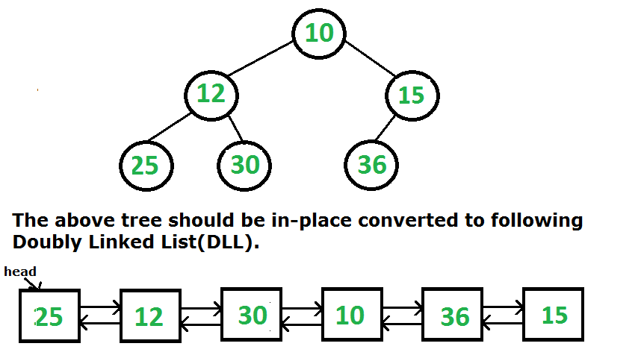](http://d2o58evtke57tz.cloudfront.net/wp-content/uploads/TreeToList.png)

Following two different solutions have been discussed for this problem.  
[Convert a given Binary Tree to Doubly Linked List | Set 1](http://www.geeksforgeeks.org/in-place-convert-a-given-binary-tree-to-doubly-linked-list/)  
[Convert a given Binary Tree to Doubly Linked List | Set 2](http://www.geeksforgeeks.org/convert-a-given-binary-tree-to-doubly-linked-list-set-2/)

In this post, a third solution is discussed which seems to be the simplest of all. The idea is to do inorder traversal of the binary tree. While doing inorder traversal, keep track of the previously visited node in a variable say prev. For every visited node, make it next of prevand previous of this node as prev.